|  |  |  |  |
| --- | --- | --- | --- |
| 1 | | 11,352 | |
| **NUMERO DE FRONTERAS** | | **ENERGIA AGREGADA** | |
|  | | | |
| 33,438,732 | 101 | | 1,249,937 |
| INGRESO 2019 | DÍAS CERTIFICADOS 2019 | | ENERGIA RESPALDADA 2019 |
|  | | | |
| 34,879,441 | 152 | | 1,200,389 |
| INGRESO 2020 | DÍAS CERTIFICADOS 2020 | | ENERGIA RESPALDADA 2020 |
|  | | | |
| 23,792,585 | 102 | | 1,064,901 |
| INGRESO 2021 | DÍAS CERTIFICADOS 2021 | | ENERGIA RESPALDADA 2021 |

**HISTORICO REINTEGRO DDV**

|  |  |  |  |
| --- | --- | --- | --- |
|  | **2019** | **2020** | **2021** |
| **ENE** | - | 4.63 | - |
| **FEB** | - | 11.05 | - |
| **MAR** | - | 13.05 | - |
| **ABR** | - | - | - |
| **MAY** | - | - | 4.03 |
| **JUN** | 5.9 | - | 5.75 |
| **JUL** | 7.86 | 0.07 | 4.97 |
| **AGO** | 8.71 | 2.45 | 3.74 |
| **SEP** | 5.28 | - | 2.41 |
| **OCT** | - | 1.99 | 2.9 |
| **NOV** | - | 0.94 | - |
| **DIC** | 5.69 | 0.69 | - |

**Los valores de la tabla están en millones de COP**

**REINTEGRO MECANISMO DDV OCTUBRE 2021**

|  |  |  |  |  |  |
| --- | --- | --- | --- | --- | --- |
| FECHA | TIPO DIA | CANTIDADES RESPALDO | PRECIO PONDERADO USD | TRM | PNETO |
| 2021-10-05 | Martes | 11,351 | 5.98 | 3,784.44 | 230,168 |
| 2021-10-06 | Miércoles | 11,327 | 5.98 | 3,784.44 | 229,681 |
| 2021-10-07 | Jueves | 11,279 | 5.98 | 3,784.44 | 228,708 |
| 2021-10-08 | Viernes | 11,351 | 5.98 | 3,784.44 | 230,168 |
| 2021-10-09 | Sábado | 11,351 | 5.98 | 3,784.44 | 230,168 |
| 2021-10-10 | Domingo - Festivo | 11,013 | 5.98 | 3,784.44 | 223,314 |
| 2021-10-11 | Lunes | 10,367 | 5.98 | 3,784.44 | 210,215 |
| 2021-10-19 | Martes | 10,367 | 5.98 | 3,784.44 | 210,215 |
| 2021-10-20 | Miércoles | 10,391 | 5.98 | 3,784.44 | 210,702 |
| 2021-10-21 | Jueves | 11,279 | 5.98 | 3,784.44 | 228,708 |
| 2021-10-22 | Viernes | 11,351 | 5.98 | 3,784.44 | 230,168 |
| 2021-10-23 | Sábado | 11,015 | 5.98 | 3,784.44 | 223,355 |
| 2021-10-24 | Domingo - Festivo | 10,367 | 5.98 | 3,784.44 | 210,215 |

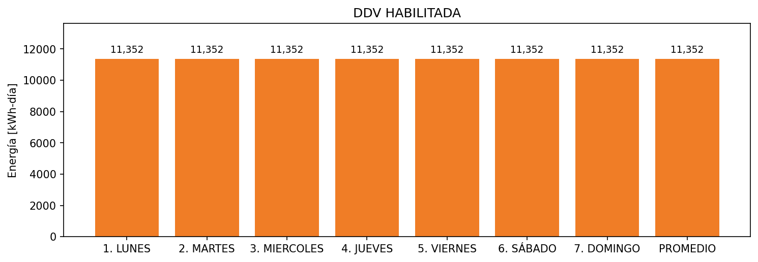

|  |  |  |  |  |  |  |  |  |  |
| --- | --- | --- | --- | --- | --- | --- | --- | --- | --- |
| **FRONTERA** | **COD SIC** | **FRT DDV** | **TIPO DDV** | **PROMEDIO** | **PRÓXIMA ACTUALIZACIÓN** | **MARGEN DE ERROR** | **ÚLTIMA PRUEBA DDV** | **DÍAS PARTICIPACIÓN** | **FECHA REFERENCIA PRÓXIMA PRUEBA DDV** |
| ESTELAR INTERCONTINENTAL | Frt10951 | Frt32697 | LBC | 11,352 | 2022-02-23 | 3,29 | 2021-10-04 | 13.0 | 2022-02-25 |